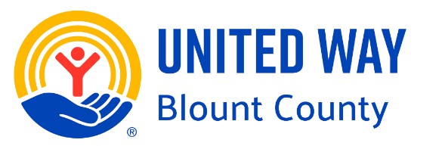
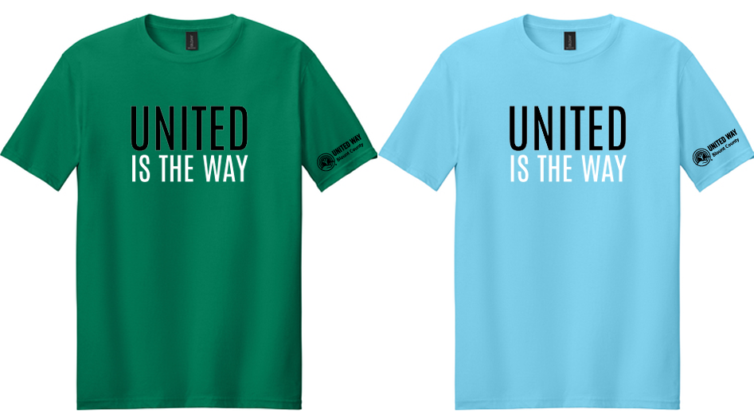

Adult | Kelly Green | Sky Blue
Small
Medium
Large
X Large
2XL
3XL
Both shirts are Gildan 64000 Softstyle, 100% ring spun cotton

Your company can receive up to 10 shirts at no cost, then $9 each after that.
(United Way will send an invoice)

Name: _________________________

Company: _______________________

Phone: __________________________

Email: _____________________________________________________

